**LECTURE 2**

**INTELLIGENT AGENTS IN AI**

**What are agents?**

* An agent is anything that can be viewed as perceiving its environment through sensors and acting upon that environment through actuators.

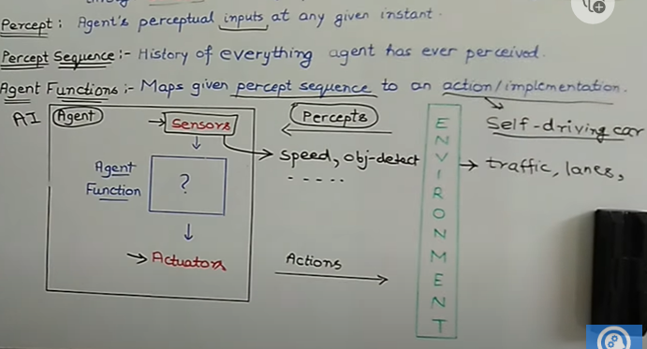

Actions can be breaks or accelerators.

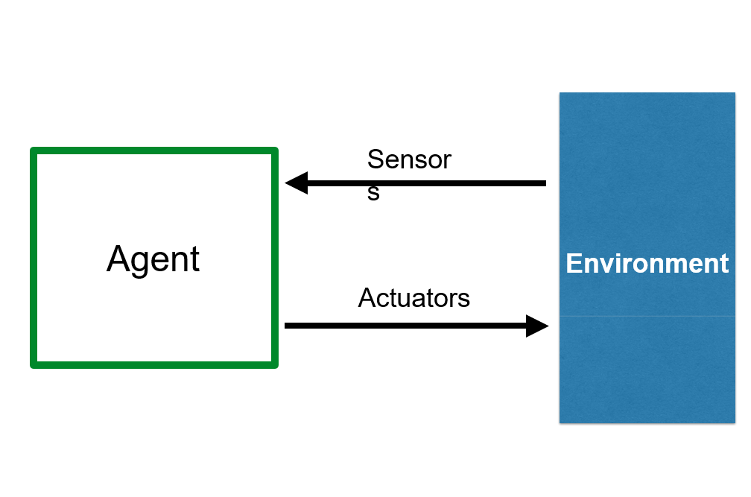

**RATIONAL AGENTS**

* A **rational agent** is one that acts so as to achieve the best outcome or, when there is uncertainty, the best expected outcome.

Rationality depends on

1. Performance measure
2. Agents prior knowledge(Environment)
3. Actions that agent can perform(Actuators)
4. Agents percept sequence(sensors) – History of what the agent has perceived from the environment.

This 4 factors are known as PEAS, We call all of this dependencies as a task environment.

**PERFORMANCE MEASURE**

Agent can be a software or a program that can perceive the environment. The agent will use the sensor to perceive the environment and using actuators it will perform the actions on the environment, after performing the actions it will make some changes in the environment. So it will change the state of the environment to various other states. If the changes made to the environment are the desired actions or the desired changes that we really wanted the AI agent to make so this is known as the notion of desirability.

Rational Agent – For each possible percept sequence a rational agent should select an action that is expected to maximise it performance measure, given percept sequence and prior knowledge.

**FULLY OBSERVABLE VS PARTIALLY OBSERVABLE**

**Fully Observable:** Agent’s sensors give it access to the complete state of the environment at each point in time.

Examples:

Chess – the board is fully observable, and so are the opponent’s moves.

Tic -tac- toe, connect four, checkers are some other games which are fully observable

**Partially Observable:** Environment might be partially observable because of noisy and in accurate sensors or because parts of the state are simply. Those environments you need memory on the side of the agent to make the best possible decision.

When an agent sensor is capable to sense or access the complete state of an agent at each point in time, it is said to be a fully observable environment else it is partially observable.

Maintaining a fully observable environment is easy as there is no need to keep track of the history of the surrounding.

An environment is called unobservable when the agent has no sensors in all environments.

Examples:

Driving – the environment is partially observable because what’s around the corner is not known.

Game of Poker - each player has access only to their own cards and the community cards on the table. They do not know the cards held by other players.

Financial Markets: Trading in financial markets can be considered a partially observable environment. Traders have access to historical and real-time data, but they do not have complete knowledge of the intentions or actions of other traders or market conditions. Traders make decisions based on incomplete information, using market indicators and statistical models.

**DETERMINISTIC VS SOCHASTIC**

When a uniqueness in the agent’s current state completely determines the next state of the agent, the environment is said to be deterministic.

Examples:

Chess – there would be only a few possible moves for a coin at the current state and these moves can be determined.

The stochastic environment is random in nature which is not unique and cannot be completely determined by the agent.

Examples:

Self-Driving Cars- the actions of a self-driving car are not unique, it varies time to time.

Weather Simulation: Simulating weather patterns can be considered a stochastic environment. Weather conditions are influenced by a wide range of complex factors, such as temperature, humidity, and atmospheric pressure. Predicting the exact weather in the future involves dealing with inherent uncertainty and probabilistic models.

Rolling a die

**STATIC VS DYNAMIC**An environment that keeps constantly changing itself when the agent is up with some action is said to be dynamic.

Examples:

A roller coaster ride is dynamic as it is set in motion and the environment keeps changing every instant.

Traffic Network: A traffic network is a classic example of a dynamic environment. The flow of vehicles, changing traffic conditions, traffic lights, and the interactions between vehicles create a constantly evolving and dynamic system.

Weather System: Weather is a highly dynamic environment influenced by various factors such as temperature, wind patterns, humidity, and atmospheric pressure. It undergoes continuous changes, leading to shifting weather conditions, including rain, snow, storms, and sunny periods.

An idle environment with no change in its state is called a static environment.

Examples:

An empty house is static as there’s no change in the surroundings when an agent enters.

Puzzle: Various puzzles, such as jigsaw puzzles or Sudoku, can be seen as static environments. The arrangement of pieces or numbers remains fixed, and the goal is to find the correct solution within the given constraints.

Chess (without time constraints): In a game of chess without any time constraints or a clock, the environment can be considered static. The positions of the pieces and the rules of the game remain constant, and the players can take their time to make decisions.

**DISCRETE VS CONTINUOUS**

A discrete environment is one where you have finitely many choices.

If an environment consists of a finite number of actions that can be deliberated in the environment to obtain the output, it is said to be a discrete environment.

The game of chess is discrete as it has only a finite number of moves. The number of moves might vary with every game, but still, it’s finite.

Tic-Tac-Toe: Tic-Tac-Toe is a well-known game played on a 3x3 grid. The state of the game is discrete and can be represented by the arrangement of X's and O's on the board. The actions available to the players are also discrete, corresponding to placing their symbol in an empty cell.

Rubik's Cube: Although Rubik's Cube has a large state space, it can be considered a discrete environment. The cube's state can be represented by the arrangement of its colored stickers, and the actions are discrete moves that rotate the cube's layers.

The environment in which the actions are performed cannot be numbered i.e. is not discrete, is said to be continuous.

Self-driving cars are an example of continuous environments as their actions are driving, parking, etc. which cannot be numbered.

**BENIGN VS ADVERSERIAL ENVIRONMENT**

Benign environment - The environment has no objective that would “go against” what you're trying to accomplish.

Examples:

Adversarial environment – The environment observes you and contradict what you're trying to achieve.

Episodic vs Sequential

In an Episodic task environment, each of the agent’s actions is divided into atomic incidents or episodes. There is no dependency between current and previous incidents. In each incident, an agent receives input from the environment and then performs the corresponding action.

Example: Consider an example of Pick and Place robot, which is used to detect defective parts from the conveyor belts. Here, every time robot(agent) will make the decision on the current part i.e. there is no dependency between current and previous decisions.

In a Sequential environment, the previous decisions can affect all future decisions. The next action of the agent depends on what action he has taken previously and what action he is supposed to take in the future.

Example:Board Games: Board games such as Chess, Checkers, or Go are sequential environments. The actions taken by players in each turn affect the subsequent state of the game and ultimately determine the outcome. The game progresses sequentially as each player takes turns based on the current state.

**SINGLE AGENT VS MULTI AGENT**

An environment consisting of only one agent is said to be a single-agent environment.

Example: A person left alone in a maze is an example of the single-agent system.

Solitaire: Solitaire is a card game that is typically played by a single player. The player makes decisions and takes actions to rearrange the cards on the playing surface with the objective of reaching a winning state.

An environment involving more than one agent is a multi-agent environment.

Example: The game of football is multi-agent as it involves 11 players in each team.

**STRUCTURE OF RATIONAL AGENT**

Agent = Architecture + program

Architecture is the machinery that the agent executes on. It is a device with sensors and actuators, for example: a robotic car, a camera, a PC.

Agent program is an implementation of an agent function. An agent function is a map from the percept sequence to an action.

**TYPES OF RATIONAL AGENTS**

* Simple Reflex Agents
* Model Based Reflex Agents
* Goal Based Agents
* Utility Based Agents
* Learning Agents